Application of Agile Methodology in the SIAK Mini
Project using Taiga and Github

Name : Radingka Rocha Arfian
Student ID : 255150200111014
Study Program : Informatics Engineering
Class : TIF-B
Lecturer : Dr. Achmad Arwan, S.Kom., M.Kom.

TABLE OF CONTENTS
Contents
TABLE OF CONTENTS 2
CHAPTER I 4
INTRODUCTION 4
1.1 Background 4
1.2 Problem Statement 4
1.3 Objectives 4
1.4 Benefits 4
CHAPTER II 5
THEORETICAL FRAMEWORK 5
2.1 Agile Methodology 5
2.2 Scrum Framework 5
2.3 Taiga Project Management 5
2.4 GitHub Platform 5
2.5 Taiga and GitHub Integration 6
CHAPTER III 7
DISCUSSION 7
3.1 SIAK Mini Design Implementation in Taiga 7
3.1.1 Project Creation 7
3.1.2 Project Configuration 11
3.1.3 Project Execution 12
CHAPTER IV 15
RESULTS AND ANALYSIS 15
4.1 Sprint Implementation Result 15
CHAPTER V 16
CONCLUSION 16
5.1 Conclusions 16
APPENDICES 17
REFERENCES 19

Figure 3 1 New Project Interface 7
Figure 3 2 Add User Story Interface 8
Figure 3 3 New Sprint Interface and Added Sprint 9
Figure 3 4 New Task Interface 10
Figure 3 5 Example of Filled Task Interface 11
Figure 3 6 Example of Filled Task Interface 11
Figure 3 7 Programming Example 12
Figure 3 8 Commit File 13
Figure 3 9 Taiga and Github Webhook Configuration 14

Figure 6 1 Backlog Interface 17
Figure 6 2 Sprint 1 Interface 17
Figure 6 3 Github Repository Interface 18

CHAPTER I

INTRODUCTION

1.1 Background
Today, managing software development projects requires precise methodologies to ensure efficiency and quality. Higher education institutions with many academic aspects need integrated information systems to manage the complex flow of data and processes efficiently. SIAK (Sistem Informasi Akademik) in mini size is designed to simulate academic data management project on a focused and efficient scale.
Developing the project requires a structured and flexible project management approach. Agile methodology, precisely with scrum framework is one of proven approach in software development because of its iterative nature and adaptability when facing changes. Implementing this methodology requires project management tools that support effective support team collaboration and transparent progress tracking.
Taiga, an agile-based project management website, provides many framework, including scrum. For scrum framework, taiga has user story mapping and sprint planning that also comes with custom tag for efficient team organization. Integrating github to taiga enables synchronization and transfer log, enhancing development efficiency and project progress transparency.

1.2 Problem Statement
Based on the background, the identified problems are:
- How to utilize taiga project management to manage user stories and sprint planning after system design?
- How to integrate github to taiga to enhance team collaboration efficiency?

1.3 Objectives
The objectives of this project are:
- Utilize taiga project management to implement agile methodology with scrum framework
- Integrate github to taiga for commits and issues synchronizing related to user stories

1.4 Benefits
The expected benefits of this project are:
- Enhance ability to apply agile methodology and scrum framework
- Increase practical experience using modern project management tools (taiga)
- improved skill in team collaboration using github
- Increase understanding of a structured software development workflow

CHAPTER II

THEORETICAL FRAMEWORK

2.1 Agile Methodology
Agile is a methodology aims to deliver features into smaller tasks within short duration of time by iterations that consists pre-planning, planning, release planning, iteration planning, and manage product backlog. Agile comes into the software industry as an answer of fast-paced industry that requires rapid responses to ever-changing demands. Currently, agile is one of well-known software development process/strategy.

2.2 Scrum Framework
Scrum is one of the most popular agile framework for managing complex adaptive problems. It provides steps to control the software and product development process. It comprises three components, roles, ceremonies, and artifacts. The roles comprises product owner, scrum master, and the product developmental team. The ceremonies of the framework include the sprint planning as the goals and the sprint backlog, chosen from decided product backlog. The scrum master’s goal is to teach and mentor the team and remove any complexities and problems.

2.3 Taiga Project Management
Taiga is an open-source project management tool for multi role that work in agile with scrum and kanban framework. It named after boreal forest which lies across the subarctic region that strikingly beautiful from distance but deadly if enter unprepared. Taiga provides intuitive and flexible interface for tasks, such as backlog management, sprint planning. It also can be self-hosted and integrates with other development tools like github.

2.4 GitHub Platform
Github is a web-based proprietary developer platform that allows developer to create, store, mange, and share their code. Github aims to build software-faster, smarter, and more securely. It commonly used to deliver scalable and secure solution for every team sizes. It also has github copilot to automate tasks, enhance code quality and productivity with intelligent and adaptive recommendations. Github also come with integrated tools that keep the team aligned and reduce manual tasks.

2.5 Taiga and GitHub Integration
Taiga has advantage of intuitive and flexible interface for tasks. Github has advantage of code repository of task automation, code quality enhancing, and secure solution for team. with integration of both of tools, It bridges the gap for student to support learning about teamwork and project management in near-to-real-world scenarios. Taiga holds the acceptance criteria check, pattern check, task with EE, closed tasks with AE, deviation effort estimation, unassigned tasks, tasks sd, commits task reference, and commits sd on project while tasks, closed tasks, commits, modified lines on github. One of the way to integrate both of them is with webhook.
Webhook is a feature that provide a way for notifications to be delivered whenever certain events occur to an external web server. Webhook let the user subscribe to events that happening in a software system to user’s server by automatically receive a delivery of data. Webhook also used in various scenarios, such as triggering CI (continuous integration), sending notifications events from github, updating like jira about external issue, deploying to a production server, and audit purposes.

CHAPTER III

DISCUSSION

3.1 SIAK Mini Design Implementation in Taiga

3.1.1 Project Creation
1. Create New Project
After creating and login on an account, create new project in scrum template with the title and description based of the planned software design. In this case, the title is “SIAK Mini” and the description is “Sistem pencatat hubungan bimbingan antara Dosen dan Mahasiswa”.
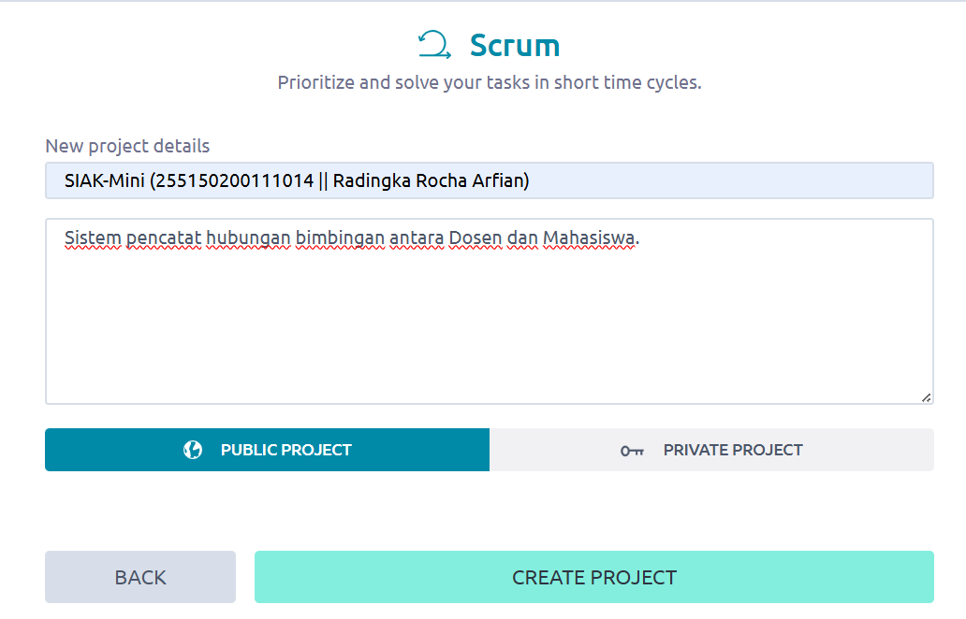
Figure 3 1 New Project Interface

2. Create New User Story
On the backlog desktop, press “+ USER STORY” button and insert the description and the subject based of the designed user story. The description is the user story sentence and the subject is the short summary of the user story. In this case the subject is “Dosen dapat menambahkan mahasiswa” from user story in the description “Sebagai dosen, saya ingin menambahkan mahasiswa ke daftar bimbingan saya, agar data bimbingan selalu terupdate”.
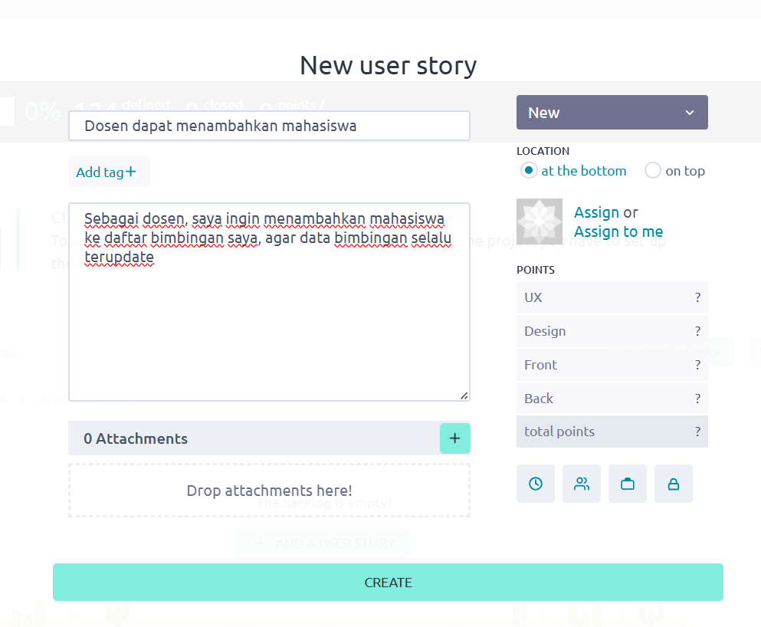
Figure 3 2 Add User Story Interface

3. Create New Sprint
After recreating every user story in taiga’s user story backlog, create new sprint with the “add+” button on the upper right corner based on designed sprint on taiga with the sprint title based on the features to be achieved in that sprint. In this case, the first sprit is “Pencatatan Hubungan Bimbingan” with one week as the time constrain. Then, drag the user story to the sprint based on designed sprint plan.
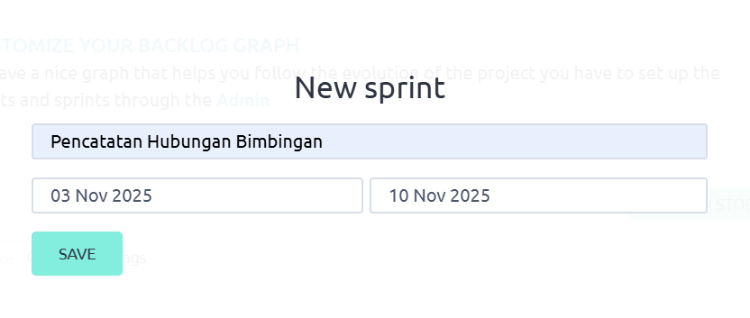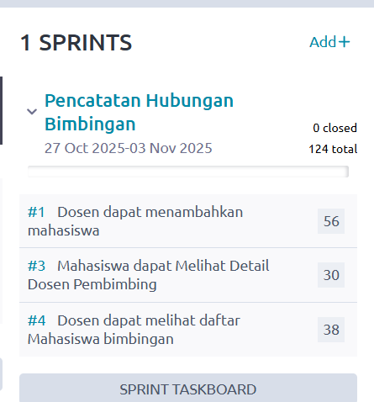
Figure 3 3 New Sprint Interface and Added Sprint

4. Create New Task
After filling the sprint with user stories, create new task on the “+” button on the user story block in sprint interface based on designed task plan. In this case, one of task on the first card is “Tambahkan atribut List mahasiswa mahasiswaBimbingan ke class Dosen.” as the description with the subject “Tambahkan atribut List mahasiswaBimbingan ke class Dosen” as the short summary of the description.
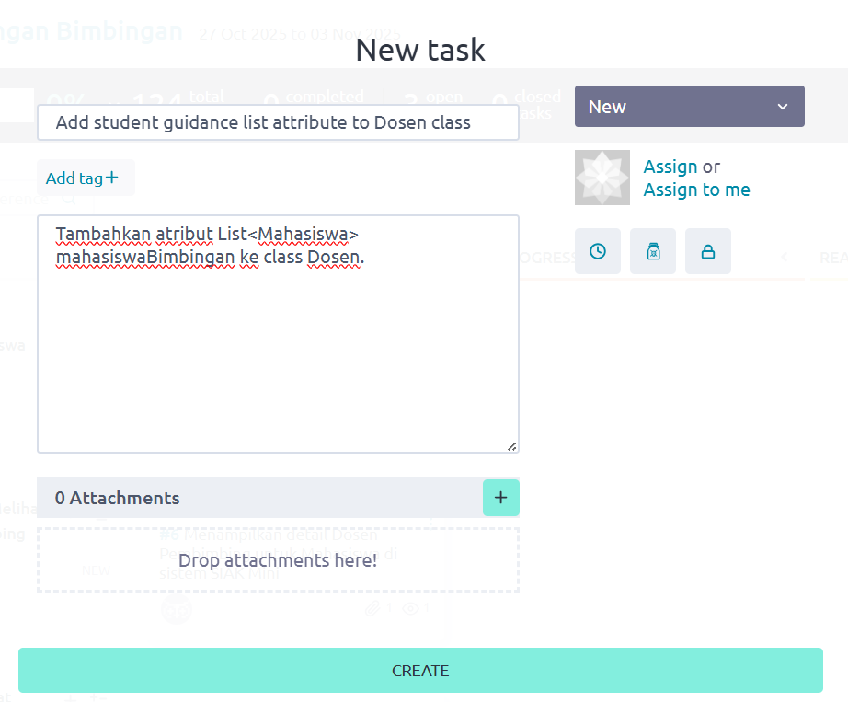
Figure 3 4 New Task Interface

3.1.2 Project Configuration
1. User Story Configuration
Adding priority point to user story would help the team to align user story from the most crucial to less important. Adding tag and organizing the role in the interface also help to minimizing team miscommunication and increase team proficiency with attachment if there is additional documentation.
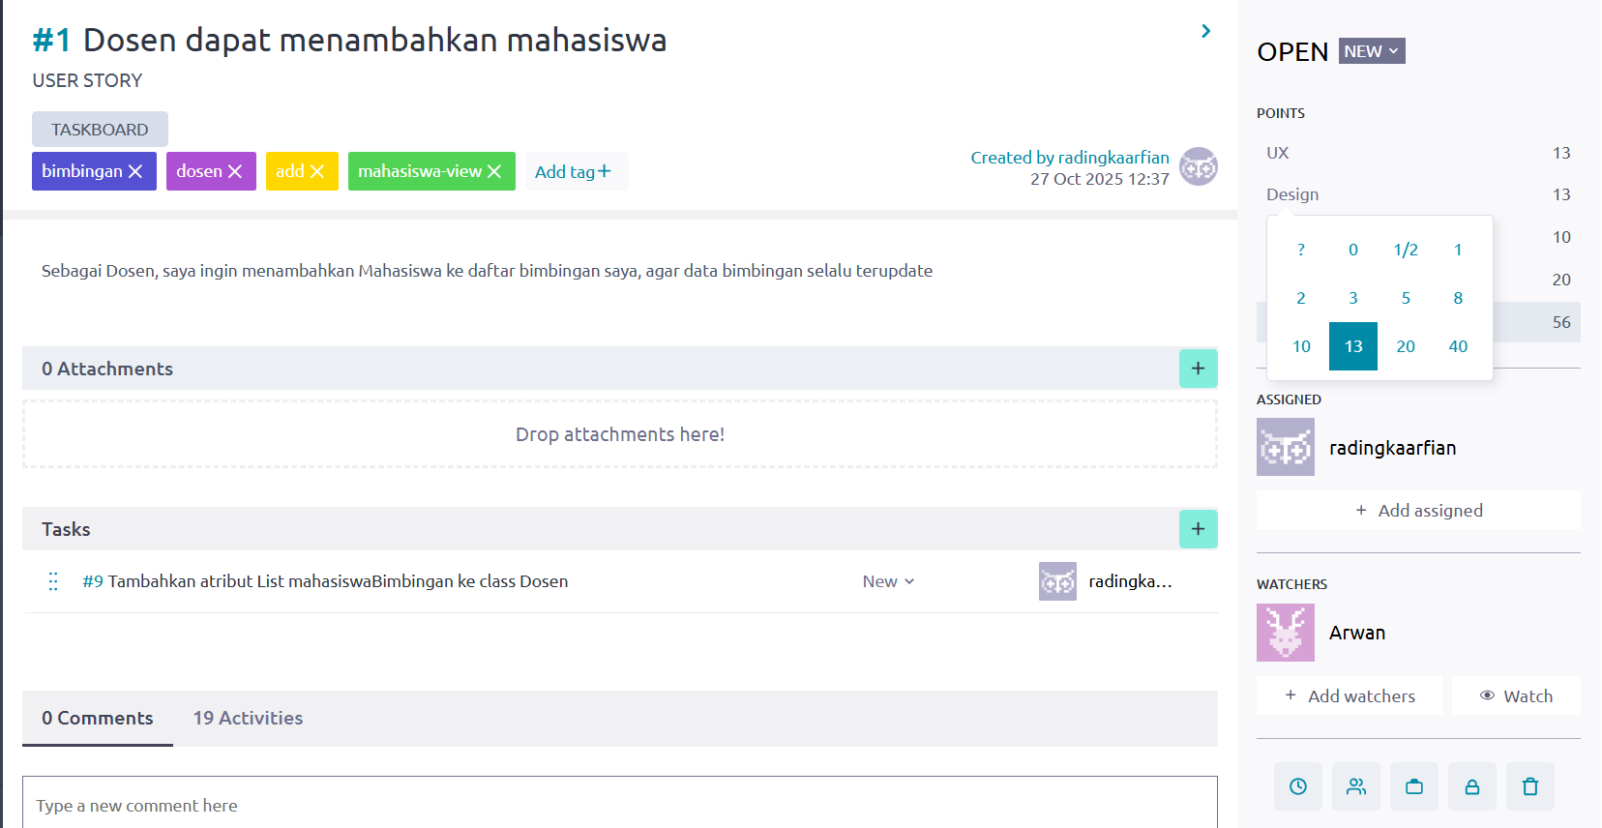
Figure 3 5 Example of Filled Task Interface
2. Task Configuration
Adding tag and organizing the role in the task interface would support team efficiency and coordination, with attachment as the reference for task details and additional documentation.
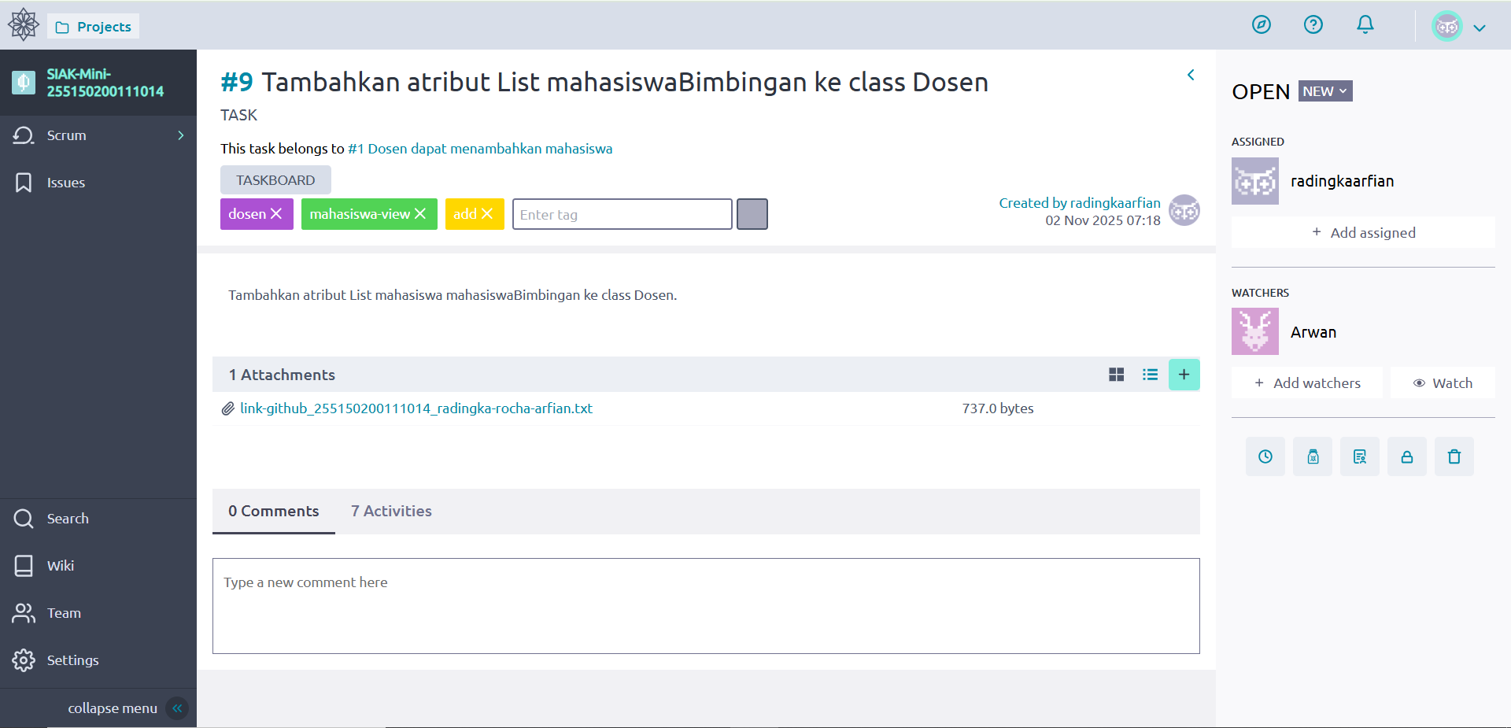
Figure 3 6 Example of Filled Task Interface

3.1.3 Project Execution
1. Programming Task
After the task and the design are clear, implement the assigned task. In this case, creating Dosen.java, Mahasiswa.java, and Main.java.
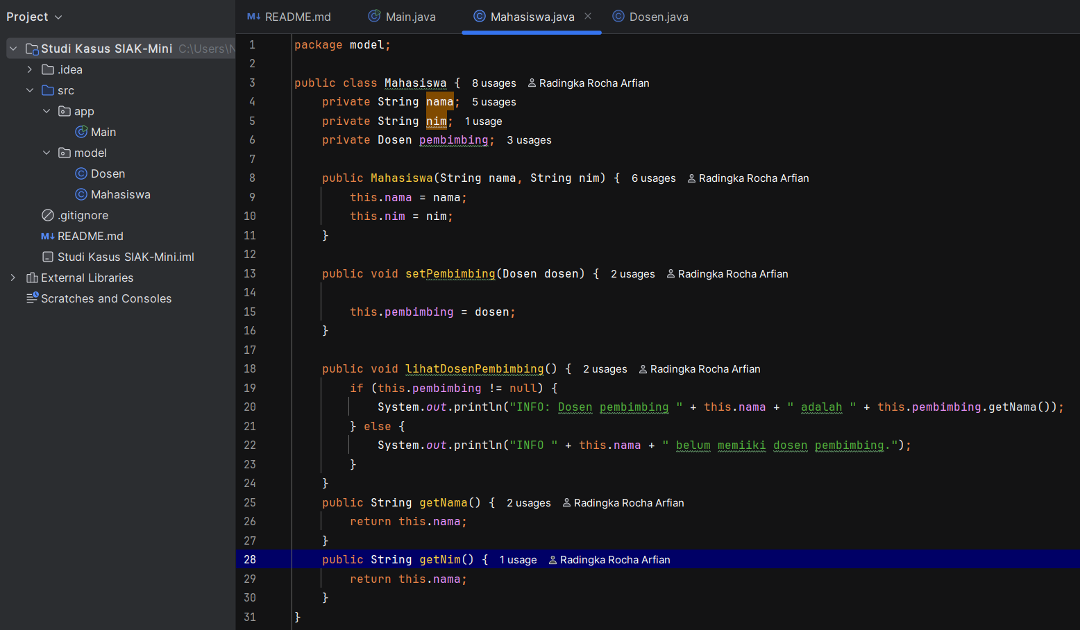
Figure 3 7 Programming Example

2. Github Repository
After the programming is ready to deploy, commit the local data to github repository using “share to github button” if using intellij IDE.
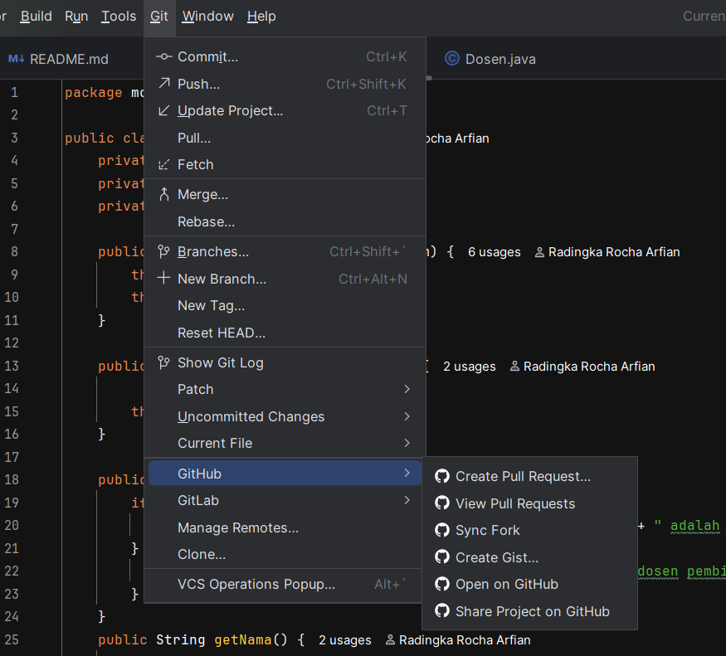
Figure 3 8 Commit File

3. Webhook Configuration
After the github repository is added, go to repository interface, then click setting > webhook > add webhook. Add the webhook using secret key and payload link from taiga with content type “application/json” that can be found on project interface, then click Settings > INTEGRATIONS > GITHUB.
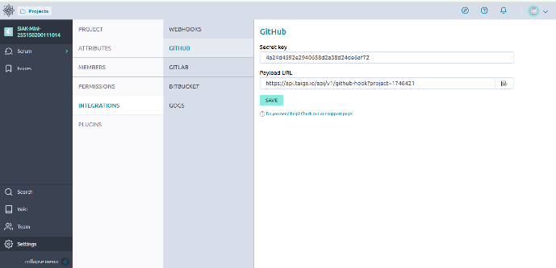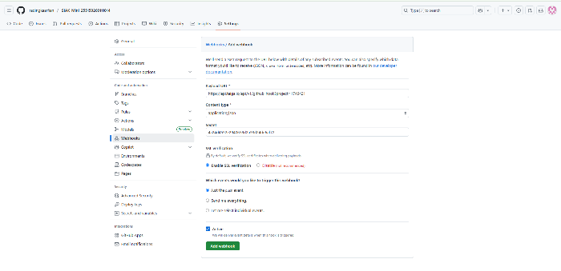
Figure 3 9 Taiga and Github Webhook Configuration

CHAPTER IV

RESULTS AND ANALYSIS

4.1 Sprint Implementation Result
Sprint 1 – Pencatatan Hubungan Bimbingan
After Implementing SIAK Mini design using taiga and github as tools, sprint 1 contains 86 total of points, with 23 for UX, 23 for Design, 15 for Front, 25 for Back as points per role. Programmed code commited in SIAK-Mini-255150200111014 github repository.
Planned User Stories
Sprint 1
US-001: "Sebagai Dosen, saya ingin menambahkan Mahasiswa ke daftar bimbingan."
Task 1: Tambahkan atribut List mahasiswaBimbingan ke class Dosen.
Task 2: Buat metode tambahMahasiswaBimbingan(Mahasiswa mhs) di class Dosen.
Task 3: Buat unit test untuk memverifikasi metode tambahMahasiswaBimbingan.
US-002: “Sebagai Mahasiswa, saya ingin melihat detail Dosen Pembimbing saya, agar saya tahu siapa yang harus dihubungi untuk konsultasi.”

CHAPTER V

CONCLUSION

5.1 Conclusions
This project successfully demonstrated the practical implementation of agile methodology using scrum framework in developing SIAK Mini through integration of taiga project management and github. The Utilization of taiga proved effective in managing user stories, sprint planning, and task organization. The integration with github through webhook configuration creating unified workflow that bridged the gap between planning and implementation. This implementation demonstrated that agile approach can deliver functional increments while maintaining flexibility with proper tool support to adapt changing requirements on development process.

APPENDICES
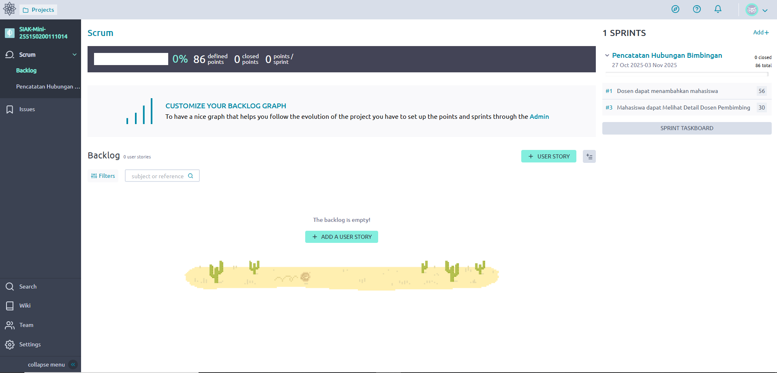
Figure 6 1 Backlog Interface
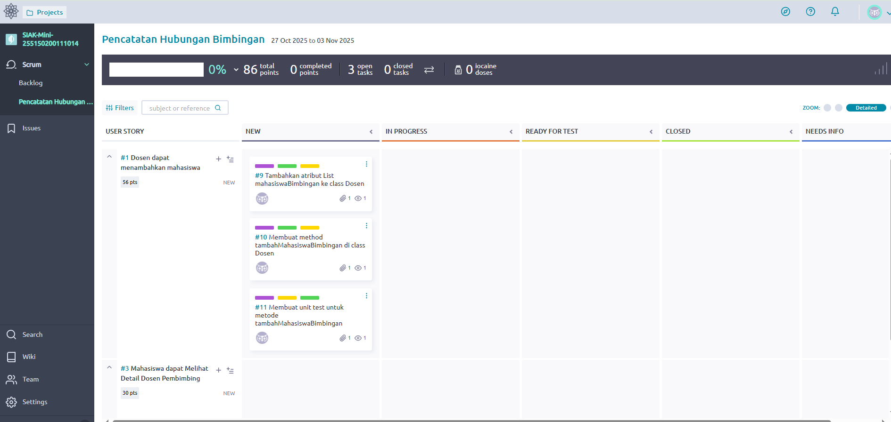
Figure 6 2 Sprint 1 Interface
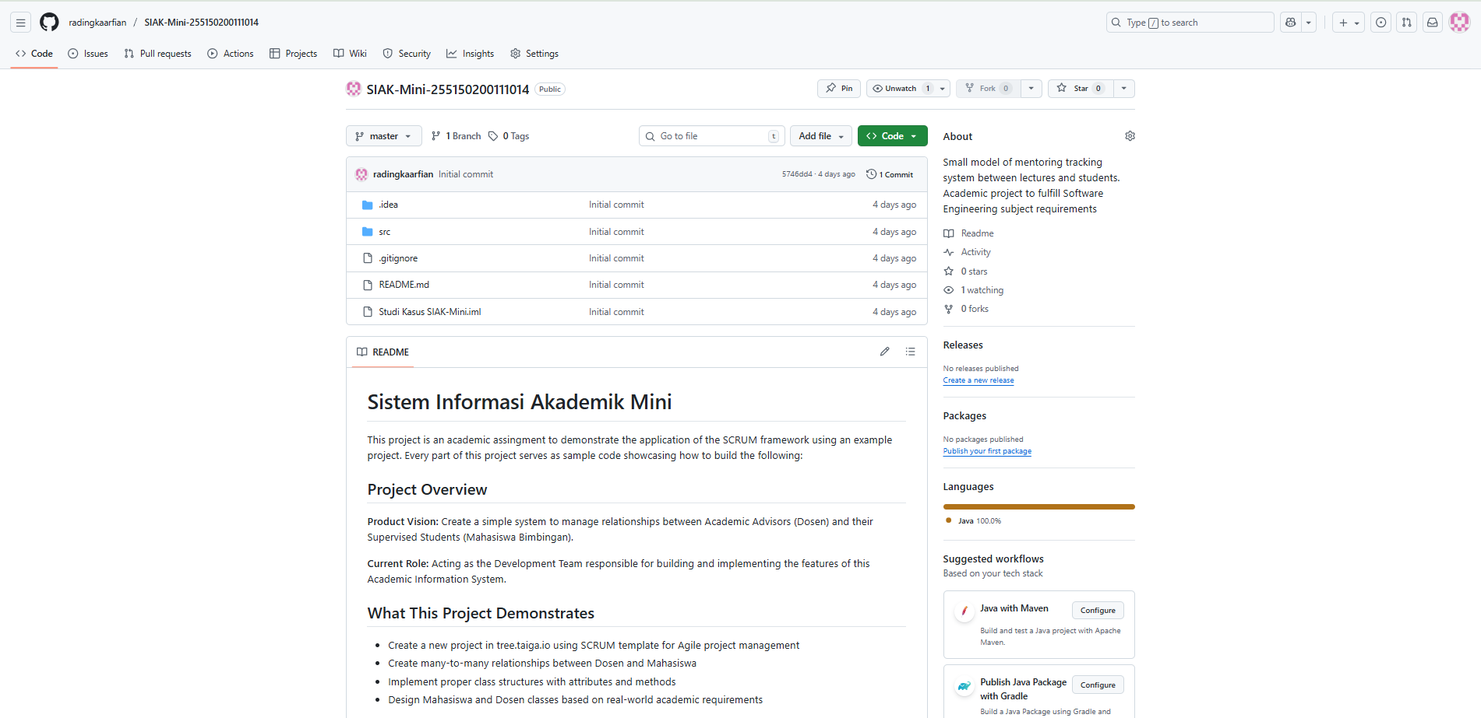
Figure 6 3 Github Repository Interface

Link Taiga:
https://tree.taiga.io/project/radingkaarfian-siak-mini-255150200111014-radingka-rocha-arfian/backlog
Link Github:
https://github.com/radingkaarfian/SIAK-Mini-255150200111014.git

REFERENCES

Farre, C., Lopez, L., Oriol, M., and Franch, X., 2025. LD@Taiga: An Embedded Learning Dashboard for Agile Project Management in Student Teams. Universitat Politècnica de Catalunya, [online] pp. 242-248. Available at: <https://upcommons.upc.edu/server/api/core/bitstreams/7ab997e5-6daf-4ab1-af18-5c4face0fb3a/content>
Waja, G., Shah, J., Nanavati, P., 2021. Agile Software Development. IT Department, KJSCE, [online] 5(12), pp 73-78. Available at: <https://www.researchgate.net/publication/354201110_AGILE_SOFTWARE_DEVELOPMENT>
Taiga.io. (n.d.). About us. [online] Available at: https://taiga.io/about-us/ [Accessed 1 Nov. 2025].
GitHub. (n.d.). Why GitHub. [online] Available at: https://github.com/why-github [Accessed 1 Nov. 2025].

